
American International University-Bangladesh (AIUB)
Faculty of Science and Technology
Automated Financial News Analysis and Recommendation Generation Using Deep Learning and Large Language Models
Md Tanvir Islam Akib (22-47816-2)
Muzahidul Islam Saki (22-47819-2)
Emon Das (22-46599-1)
Mashudh Ahmed (22-47811-2)

A Thesis submitted for the degree of Bachelor of Science (BSc) in
Computer Science and Engineering (CSE) at
American International University Bangladesh (AIUB)
Faculty of Science and Technology (FST)

Fall 2025-2026 Semester
Submission Date: 20/04/2026

Declaration

This thesis represents our original work and does not contain any material previously published or written by others, except where proper references have been clearly acknowledged in the text. The contributions of others to this study, such as aid with statistical analysis, survey design, data processing, technical implementation, editorial advice, and any other pertinent support, have been duly acknowledged.
This thesis's content is the result of our efforts since the start of the study period. We also understand that all of the contents in this thesis are still protected by their respective copyright holders. Permission to copy such items has been secured when needed, and appropriate attribution has been given. The approval of co-authors has been appropriately obtained in the case of collaboratively authored work.

_______________________________  Md Tanvir Islam Akib  22-47816-2  Computer Science and Engineering (CSE) | _______________________________  Muzahidul Islam Saki  22-47819-2  Computer Science and Engineering (CSE)
_______________________________  Emon Das  22-46599-1  Computer Science and Engineering (CSE) | _______________________________  Mashudh Ahmed  22-47811-2  Computer Science and Engineering (CSE)

Approval

The thesis titled "Automated Financial News Analysis and Recommendation Generation Using Deep Learning and Large Language Models" has been submitted to the following respected members of the board of examiners of the department of computer science in partial fulfilment of the requirements for the degree of Bachelor of Science in Computer Science and Engineering on 20 April, 2026 and has been accepted as satisfactory.

________________________________  SHAIKAT DAS JOY  Lecturer & Thesis Supervisor  Department of Computer Science  American International University-Bangladesh | ________________________________  MIR MD. KAWSUR  External Examiner  Department of Computer Science  American International University-Bangladesh
________________________________
DR. MUHAMMAD FIROZ MRIDHA
Professor & Head (UG)
Department of Computer Science
American International University-Bangladesh

________________________________ ________________________________
PROF. DIP NANDI MASHIOUR RAHMAN
Professor & Associate Dean Sr. Associate Professor & Dean
Faculty of Science & Technology Faculty of Science & Technology
American International University-Bangladesh American International University-Bangladesh

Acknowledgement

First and foremost, all praise and gratitude belong to Allah, the Most Gracious, the Most Merciful, for granting the strength, patience, and perseverance to complete this research.
We extend our sincere and heartfelt gratitude to our thesis supervisor for their unwavering guidance, scholarly expertise, and continuous encouragement throughout the course of this research. Their constructive feedback and mentorship have been instrumental in shaping the direction and quality of this work.
We are also deeply thankful to the Department of Computer Science at American International University-Bangladesh (AIUB) for providing the necessary academic infrastructure, research environment, and resources that made this study possible.
We would like to express our appreciation to the Faculty of Science and Technology for maintaining a stimulating and supportive research culture. Special thanks go to the course coordinators and faculty members whose lectures and discussions enriched our conceptual understanding of natural language processing, machine learning, and large language models.
We are grateful to our family members and friends who stood by us with patience and moral support during the most challenging phases of this research journey.
Finally, we acknowledge the open-source community and the organizations behind the Hugging Face Transformers library, Google Colab for making cutting-edge models and computational resources freely accessible to researchers around the world.

Author Contributions

Tanvir Islam Akib

Muzahidul Islam Saki

Emon Das

Masudh Ahmed

Comments

22-47816-2 | 22-47819-2 | 22-46599-1 | 22-47811-2
 | Perform as effective individual
3 | 2 | 2 | 2
2 | 3 | 2 | 2
2 | 2 | 3 | 2
2 | 2 | 2 | 3
 | Perform as effective team member/leader
3 | 2 | 2 | 2
2 | 2 | 3 | 2
2 | 3 | 2 | 2
2 | 2 | 2 | 3
 | Perform as effective team member/leader
2 | 2 | 3 | 2
3 | 2 | 2 | 2
2 | 3 | 2 | 2
2 | 2 | 2 | 3

0 - 3 points
Critical thinking
Reflection on feedback
Quality of work
Self-directed

0 - 3 points
Taking responsibility
Contribution
Collaboration
Working with others

0 - 3 points
Presentation delivery
Voice and tone
Enthusiasm
Creativity & Tools
use

Table of Contents
Author Contributions 5
Chapter 1 11
INTRODUCTION 11
1.1 Introduction 11
1.2 Problem Statement 11
1.3 Problem Background 11
1.4 Research Objectives 11
1.5 Research Questions 12
1.6 Motivations 13
1.7 Flow of Research 13
1.8 Significance of the Research 13
1.9 Research Contribution 13
1.10 Thesis Organization 14
1.11 Summary 14
Chapter 2 15
Literature Review 15
2.1 Introduction 15
2.2 Literature Review 15
2.2.1 Sentiment Analysis in Financial Text 15
2.2.2 BERT and Domain-Specific Financial Language Models 15
2.2.3 Text Generation with Language Models 15
2.2.4 Recommendation Generation from Financial News 16
2.3 Problem Analysis 16
2.4 Summary 17
Chapter 3 18
Proposed Model 18
3.1 Introduction 18
3.2 Feasibility Analysis 18
3.3 Requirement Analysis 18
3.3.1 Functional Requirements 18
3.3.2 Non-Functional Requirements 19
3.4 Research Methodology 20
3.5 System Design and Architecture 21
3.5.1 Branch A: Sentiment Classification Architecture 21
3.5.2 Branch B: Recommendation Generation Architecture 21
3.6 Implementation and Simulation 21
3.7 Tools and Technologies Used 21
3.8 Summary 22
Chapter 4 23
Implementation and Testing 23
4.1 Introduction 23
4.2 System Setup and Environment 23
4.3 Dataset Overview 23
4.3.1 Sentiment Classification Dataset 23
4.3.2 Recommendation Generation Dataset 24
4.4 Implementation of the System 24
4.4.1 Sentiment Classification Implementation 24
4.4.2 Recommendation Generation Implementation 24
4.5 Evaluation and Testing 25
4.5.1 Classification Evaluation Metrics 25
4.5.2 Generation Evaluation Metrics 25
4.6 Results and Discussion 25
4.6.1 Sentiment Classification Results 25
4.6.2 Confusion Matrix Analysis 28
4.6.3 ROC-AUC Analysis 29
4.6.4 Key Metrics Heatmap 30
4.6.5 Recommendation Generation Results 30
4.7 Summary 32
Chapter 5 33
Standards, Constraints and Milestones 33
5.1 Standards and Compliance 33
5.2 Sustainability Considerations 33
5.3 Societal Impact 33
5.4 Ethical Considerations 33
5.5 Security and Privacy Considerations 33
5.6 Design Constraints and Component Constraints 34
5.7 Data Constraints and Computational Constraints 34
5.8 Budget Constraints 34
5.9 Task Breakdown and Project Timeline 34
5.10 Milestones and Deliverables 35
5.11 Gantt Chart 35
5.12 Summary 35
Chapter 6 36
Conclusion 36
6.1 Summary of the Study 36
6.2 Key Contributions 36
6.3 Limitations of the Study 37
6.4 Future Work 37
References 38
Appendix 40
Appendix A: Sample Generated Recommendations 40
Appendix B: Hyperparameter Configuration Summary 40

List of Abbreviations

AI | Artificial Intelligence
NLP | Natural Language Processing
ML | Machine Learning
DL | Deep Learning
BERT | Bidirectional Encoder Representations from Transformers
LLM | Large Language Model
T5 | Text-to-Text Transfer Transformer
FLAN | Fine-tuned Language Net
ROUGE | Recall-Oriented Understudy for Gisting Evaluation
BLEU | Bilingual Evaluation Understudy
ROC | Receiver Operating Characteristic
AUC | Area Under the Curve
F1 | F1 Score (Harmonic Mean of Precision and Recall)
CSV | Comma-Separated Values
TBS | The Business Standard
CSE | Computer Science and Engineering
AIUB | American International University-Bangladesh
GPU | Graphics Processing Unit
FST | Faculty of Science and Technology

Abstract

The rapid expansion of digital financial media has resulted in a massive volume of unstructured textual data, which holds significant value for investors, analysts, and policymakers. However, extracting useful insights from massive amounts of financial news by hand continues to be a significant challenge. In order to solve this issue, this thesis suggests a dual-branch deep learning architecture that uses automated sentiment analysis and suggestion creation from financial news.

In the first phase, approximately 8,000 financial news articles were collected from three major Bangladeshi news sources — The Business Standard (TBS), The Daily Star, and The Financial Express — using automated web scraping techniques. From this dataset, 1,700 articles were manually annotated with sentiment labels (Positive, Negative, Neutral) to construct a ground-truth dataset. Three transformer-based models — bert-base-uncased, ProsusAI/finbert, and yiyanghkust/finbert-tone — were fine-tuned using an 80/10/10 train-validation-test split for sentiment classification. Among them, bert-base-uncased achieved the best performance, with a test accuracy of 71.2%, an F1-macro score of 0.704, and an ROC-AUC of 0.863.

In the second phase, 718 articles identified as negative were selected for recommendation generation. For each article, domain expert-authored recommendation texts were created, forming a parallel dataset for supervised text generation. Three language models — T5-Small, FLAN-T5-Small, and TinyLlama-1.1B (used as a zero-shot baseline) — were trained and evaluated using the same data split strategy. Evaluation using ROUGE and BLEU metrics shows that T5-Small achieved the highest performance, with a ROUGE-L score of 0.1417, outperforming FLAN-T5 (0.1140) and the TinyLlama baseline (0.1231).

This paper presents a novel dual-pipeline NLP framework specifically designed for the financial news domain in Bangladesh, which has not received much attention in the literature. The outcomes show how well transformer-based classification and generative language models work together to automate the entire process, from unstructured news data to structured investment advice.

Keywords: financial news analysis, sentiment classification, BERT, finbert, T5, FLAN-T5, LLaMA, recommendation generation, natural language processing, deep learning, ROUGE, BLEU

Chapter 1

INTRODUCTION
_____________________________________________________________________________________________

1.1 Introduction

The financial domain produces a significant amount of textual data on a daily basis, including news reports, earnings disclosures, analyst opinions, and regulatory updates. In developing economies like Bangladesh, financial news platforms such as The Business Standard, The Daily Star, and The Financial Express play a crucial role in providing market-related information to investors, institutions, and policymakers. As the volume of such unstructured data continues to grow, the ability to efficiently process, analyze, and extract meaningful insights from it has become increasingly essential for informed decision-making.

Advancements in Artificial Intelligence (AI) and Natural Language Processing (NLP) have greatly improved the capability of machines to interpret human language. Transformer-based models, especially BERT (Bidirectional Encoder Representations from Transformers), have significantly enhanced performance in tasks such as sentiment classification. In parallel, generative models like T5, FLAN-T5, and LLaMA have enabled the automatic generation of meaningful and context-aware textual outputs. This research utilizes these modern techniques to develop an integrated system for automated financial news sentiment analysis and recommendation generation.

1.2 Problem Statement

Despite the rapid growth of financial news media in Bangladesh, there remains a notable lack of automated systems capable of processing such data and generating investment-relevant insights. Most existing NLP solutions are developed using Western financial datasets and often fail to capture the linguistic characteristics, domain-specific vocabulary, and economic context of South Asian financial journalism. Furthermore, sentiment classification alone is not sufficient for practical use — investors require not only the identification of positive or negative sentiment but also actionable recommendations derived from critical financial news. Currently, there is no integrated system that addresses this complete pipeline within the context of the Bangladeshi financial domain

1.3 Problem Background

Prior studies in financial NLP have primarily concentrated on English-language data from major Western financial markets such as the NYSE, NASDAQ, and the London Stock Exchange. Widely used datasets like the Financial PhraseBank and domain-specific models such as FinBERT were developed based on these corpora. Although these tools perform effectively within their intended environments, their performance tends to decline when applied to financial news from South Asian contexts. This is largely due to differences in linguistic patterns, domain-specific terminology, and region-specific economic factors such as import-export trends, foreign exchange volatility, government budget policies, and the dynamics of Bangladesh’s garment industry.

In addition, generating investment recommendations from financial news is a significantly more challenging task than sentiment classification. It requires not only understanding the contextual meaning of the text but also the ability to infer suitable financial actions. This aspect remains underexplored, particularly in low-resource and region-specific domains such as Bangladeshi financial news.

1.4 Research Objectives
The primary objective of this research is to design, implement, and evaluate a two-branch automated system for financial news analysis and recommendation generation. The specific sub-objectives are:
- To build a high-quality labeled corpus of Bangladeshi financial news through automated scraping and manual annotation.
- To fine-tune and compare multiple BERT-based transformer models for three-class sentiment classification (Positive, Negative, Neutral).
- To construct a parallel corpus of negative financial news articles paired with human-authored investment recommendations.
- To fine-tune and evaluate T5-Small and FLAN-T5-Small generative models for financial recommendation generation.
- To benchmark generative model performance against a zero-shot TinyLlama baseline using ROUGE and BLEU metrics.

1.5 Research Questions
This research is guided by the following key questions:
- Which BERT-based model — bert-base-uncased, ProsusAI/finbert, or yiyanghkust/finbert-tone — achieves the highest accuracy and F1 score in classifying the sentiment of Bangladeshi financial news articles?
- Can fine-tuned seq2seq language models (T5-Small, FLAN-T5) generate meaningful and contextually appropriate financial investment recommendations from negative news articles?
- How does the performance of fine-tuned small language models compare against a zero-shot large language model (TinyLlama-1.1B) for domain-specific recommendation generation?

1.6 Motivations
The motivation for this research stems from the observation that thousands of Bangladeshi retail investors make financial decisions based on news articles without access to structured analytical tools. Access to financial intelligence would be democratized by a system that could automatically assess news mood and produce initial investment suggestions. Furthermore, the dearth of NLP resources for the financial sector in Bangladesh, such as labelled datasets, refined models, and benchmarks, spurred the development of original contributions that can act as starting points for further study.

1.7 Flow of Research
The research follows a structured pipeline beginning with data acquisition through automated web scraping, followed by data preprocessing and manual sentiment annotation. The labeled data is then divided into two parallel branches: a classification branch for sentiment analysis using BERT models, and a generation branch for recommendation synthesis using LLMs. Both branches undergo rigorous training, evaluation, and comparative analysis before converging to final conclusions and recommendations for future work.

1.8 Significance of the Research
This research makes several meaningful contributions. For the financial community, it provides a prototype tool capable of processing and analyzing Bangladeshi financial news at scale. For the NLP research community, it contributes a domain-specific labeled dataset and comparative benchmarks for both classification and generation tasks. For policymakers and regulators, it offers a mechanism for monitoring the sentiment landscape of financial media automatically. The dual-pipeline architecture proposed here can be extended to other languages and financial markets in the developing world.

1.9 Research Contribution
The key contributions of this thesis are:
- A manually annotated Bangladeshi financial news sentiment dataset of 1,700 articles with three sentiment classes scraped from three major financial portals.
- A comparative evaluation of three BERT-family models for financial sentiment classification, with bert-base-uncased achieving 71.2% test accuracy and ROC-AUC of 0.863.
- A novel parallel corpus of 718 negative financial news articles paired with domain expert-authored investment recommendations, created specifically for LLM fine-tuning.
- Fine-tuned T5-Small and FLAN-T5-Small models evaluated on ROUGE and BLEU metrics, with T5-Small achieving the best ROUGE-L of 0.1417.
- A full end-to-end NLP pipeline architecture for automated financial news analysis in the Bangladeshi domain.

1.10 Thesis Organization
The remainder of this thesis is organized as follows. Chapter 2 presents a comprehensive literature review covering sentiment analysis in finance, financial NLP datasets, and text generation using language models. Chapter 3 describes the proposed dual-branch model architecture, data pipeline, methodology, and tools used. Chapter 4 presents the implementation details, evaluation metrics, and results with detailed analysis. Chapter 5 discusses standards, constraints, ethical considerations, and the project timeline. Chapter 6 concludes the thesis with a summary of findings, key contributions, limitations, and directions for future research.

1.11 Summary
This chapter established the motivation and context for developing an automated system for financial news sentiment analysis and recommendation generation in the Bangladeshi context. The problem of information overload in financial media, the lack of domain-specific NLP tools, and the need for actionable investment guidance from unstructured text were clearly articulated. The research objectives, questions, and contributions outlined here define the scope and ambition of this thesis, which the subsequent chapters address in detail.

Chapter 2

Literature Review

2.1 Introduction

This chapter provides a comprehensive review of existing studies related to the main areas of this research, including financial news sentiment analysis, transformer-based models for text classification, and text generation using language models. It highlights important developments as well as existing limitations in the literature and establishes the foundation for the methodological approach adopted in this study.

2.2 Literature Review

2.2.1 Sentiment Analysis in Financial Text

Sentiment analysis, also known as opinion mining, refers to the process of determining the underlying emotional tone expressed in textual data. In the financial sector, this technique is commonly used for applications such as market trend prediction, risk evaluation, and monitoring financial news. Early methods primarily depended on lexicon-based approaches, including tools like the Harvard General Inquirer and the Loughran-McDonald financial sentiment dictionary [1]. Although these methods are simple and easy to apply, they often fail to capture context-sensitive meanings and specialized financial terminology.

With the advancement of deep learning, significant improvements have been observed in sentiment analysis performance. Models such as Convolutional Neural Networks (CNNs) and Long Short-Term Memory (LSTM) networks have outperformed traditional lexicon-based approaches on various financial datasets [2]. More recently, transformer-based architectures, especially BERT [3], have become dominant in this field. These models utilize self-attention mechanisms and bidirectional context understanding, enabling more accurate interpretation of complex financial text.

2.2.2 BERT and Domain-Specific Financial Language Models

BERT, proposed by Devlin et al. (2019) [3], significantly advanced natural language processing by introducing a pre-training approach based on masked language modeling and next sentence prediction. This framework allows the model to learn deep contextual representations of text in a bidirectional manner. When fine-tuned on task-specific labeled datasets, BERT has consistently demonstrated superior performance compared to earlier approaches across a wide range of NLP tasks.In the financial domain, Araci (2019) [4] introduced FinBERT, a domain-adapted version of BERT trained on the Financial Phrase Bank dataset. This adaptation highlights the importance of domain-specific pretraining, as FinBERT achieves improved sentiment classification performance on financial text compared to general-purpose BERT models.

Following this, several FinBERT variants have been developed. Among them, ProsusAI/finbert is a widely adopted model that has been fine-tuned on approximately 4,500 annotated sentences from the Financial PhraseBank dataset. Another variant, yiyanghkust/finbert-tone, extends the model by incorporating tone classification capabilities. While these models perform well on standard financial benchmarks, their effectiveness on non-Western and low-resource datasets—such as Bangladeshi financial news—remains relatively underexplored, which forms the motivation for this study.

2.2.3 Text Generation with Language Models

The field of automatic text generation has advanced significantly with the introduction of sequence-to-sequence transformer models. The T5 architecture (Raffel et al., 2020) [5] treats all NLP tasks within a unified text-to-text framework, allowing a single model to handle tasks such as summarization, translation, question answering, and text generation through appropriate prompting. Building on this, Google’s FLAN-T5 [6] enhances the original model through instruction-based fine-tuning on a wide range of tasks, leading to improved generalization in both zero-shot and few-shot scenarios.

For larger model baselines, open-source large language models such as LLaMA (Touvron et al., 2023) [7] and its subsequent variants have shown strong zero-shot generation performance. TinyLlama [8], a 1.1B parameter distilled version of LLaMA trained on large-scale text data, offers a more computationally efficient alternative for generation tasks. Although these models perform well in general domains, their effectiveness in specialized areas such as financial recommendation generation—particularly in South Asian contexts—remains an open research challenge.

2.2.4 Recommendation Generation from Financial News
The intersection of sentiment analysis and recommendation generation has been explored in several recent works. Zhang et al. (2022) [9] proposed a pipeline combining news sentiment classifiers with rule-based recommendation engines for stock screening. However, purely rule-based generation fails to capture the nuanced, context-specific nature of financial advisory text. Neural generation approaches using sequence-to-sequence models have been applied to financial summarization [10], but the direct generation of investment recommendations from negative news articles — as pursued in this thesis — represents a relatively underexplored and novel research direction.

2.3 Problem Analysis
The literature review reveals three key gaps that this research addresses. First, existing financial NLP models are predominantly trained on Western financial data and have not been validated on South Asian or Bangladeshi financial news, which exhibits distinct linguistic and topical patterns. Second, while sentiment analysis of financial text has been extensively studied, the downstream task of generating actionable investment recommendations from classified sentiment — particularly negative sentiment — has received limited attention. Third, comparative benchmarking of multiple fine-tuned small language models against a zero-shot large language model for domain-specific generation has not been conducted in the context of financial recommendation systems.

2.4 Summary
This chapter reviewed the foundational and contemporary literature on financial sentiment analysis, BERT-based transformer models, and generative language models. The identified gaps justify the dual-pipeline approach adopted in this thesis, which combines fine-tuned BERT variants for classification with generative LLMs for recommendation synthesis. The next chapter presents the proposed system architecture and methodology in detail.

Chapter 3

Proposed Model

3.1 Introduction
This chapter presents the proposed dual-branch deep learning pipeline for automated financial news analysis and recommendation generation. It describes the system architecture, data acquisition strategy, preprocessing methodology, model selection rationale, and the implementation tools and frameworks used throughout the research.

3.2 Feasibility Analysis

The proposed system is technically feasible due to the availability of advanced pre-trained transformer models within the Hugging Face ecosystem, along with access to cloud-based GPU platforms such as Google Colab and Kaggle, and publicly accessible Bangladeshi financial news sources. From an economic perspective, the research was carried out with minimal cost by utilizing free-tier cloud computing resources and open-source tools. Operationally, the two-stage pipeline — consisting of sentiment classification followed by recommendation generation — can be implemented sequentially without the need for specialized hardware. The main limitation of the system lies in the relatively small size of the manually annotated dataset, which was addressed through focused data collection and preprocessing strategies.

3.3 Requirement Analysis

3.3.1 Functional Requirements
- The system shall scrape financial news articles from at least three Bangladeshi financial news portals automatically.
- The system shall support manual annotation of sentiment labels (Positive, Negative, Neutral) for scraped articles.
- The system shall fine-tune and evaluate at least three BERT-based models for sentiment classification.
- The system shall extract and compile negative-sentiment articles into a sub-corpus for recommendation generation.
- The system shall fine-tune and evaluate at least two seq2seq language models for recommendation text generation.
- The system shall produce quantitative evaluation metrics including accuracy, F1, ROUGE, and BLEU scores.

3.3.2 Non-Functional Requirements
- Performance: Models must be trained and evaluated within the resource constraints of free-tier GPU platforms.
- Reproducibility: All experiments must be fully documented and reproducible from provided code and data.
- Modularity: The two branches of the pipeline must be independently operable and extensible.
- Scalability: The pipeline architecture must be extensible to larger datasets and additional news sources.
3.3.3 Dataset and variables
The dataset used in this study was constructed through automated web scraping of financial news articles from three prominent sources: The Daily Star, The Financial Express, and The Business Standard (TBS). The dataset contains approximately 1,695 news articles and includes several key variables that support both sentiment classification and recommendation generation tasks. The details of the dataset variables are presented in Table 3.1.
Feature Name | Description
Text | Financial news article content
Sentiment_Label | Sentiment category (Positive, Neutral, Negative)
Source | Source of the news (Daily Star, Financial Express, TBS)
Date | Publication date of the news article
Recommendation_Text | Manually created recommendation used as ground truth
Table 3.1: Dataset Attributes and Description
The table summarizes the structure of the dataset used in this study. The Text field contains the main news content, which serves as the primary input for both classification and generation tasks. The Sentiment_Label represents manually annotated sentiment categories used for training and evaluation of classification models. The Source and Date fields provide contextual information about each news article. Additionally, the Recommendation_Text column contains human-written recommendations, which are used as reference outputs for evaluating the performance of generative models such as T5-Small, FLAN-T5, and TinyLlama.

3.3.4 Data Preprocessing
The collected financial news data underwent several preprocessing steps to ensure data quality and compatibility with machine learning models. Initially, raw scraped data contained HTML tags, special characters, and inconsistent formatting, which were removed during the cleaning phase. All text was converted to lowercase to maintain uniformity across the dataset.
Following data cleaning, Natural Language Processing (NLP) techniques were applied. Tokenization was performed to split text into meaningful units, and stopwords such as “the”, “is”, and “and” were removed to reduce noise. Text normalization techniques were also applied to ensure consistency in representation.
For transformer-based models, the processed text was further converted into numerical format using the BERT tokenizer. This step generated input IDs and attention masks, which are required for training and inference in deep learning models.

3.4 Research Methodology
The research adopts a two-branch deep learning methodology as illustrated in Figure 1. The overall pipeline begins with Phase 1: Data Acquisition, where financial news is scraped from three sources and stored as a raw CSV dataset. Phase 2 involves preprocessing and manual human annotation to create a labeled master dataset of 1700 articles. This labeled dataset is then split along two paths: Branch A focuses on sentiment classification using fine-tuned BERT models, while Branch B isolates negative-sentiment articles and pairs them with human-authored recommendations to train generative language models. Both branches conclude with rigorous evaluation and comparison before the final thesis results are synthesized.

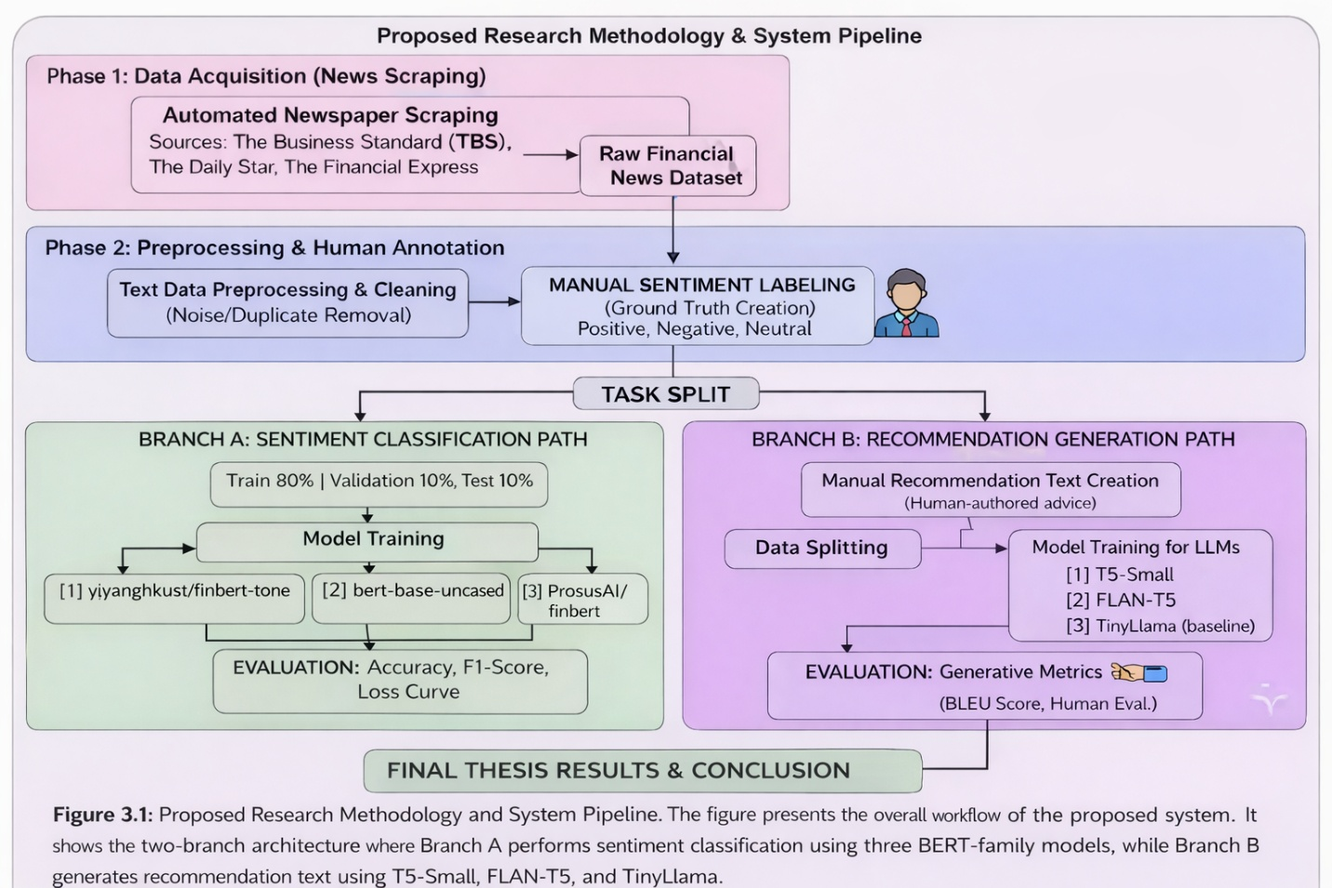
Figure 3.1: Proposed Research Methodology & System Pipeline
Figure 3.1 Proposed Research Methodology and System Pipeline. The figure presents the overall workflow of the proposed system. It shows the two-branch architecture where Branch A performs sentiment classification using three Bert-family models, while Branch B generates recommendation text using T5-small, Flan-T5, and Tiny Llama.

3.5 System Design and Architecture

3.5.1 Branch A: Sentiment Classification Architecture
The sentiment classification branch employs a standard fine-tuning paradigm for transformer-based classification. Each of the three candidate models — bert-base-uncased, ProsusAI/finbert, and yiyanghkust/finbert-tone — was loaded with a classification head consisting of a dropout layer followed by a linear projection to three output classes. The input to each model is a tokenized financial news headline or article snippet, padded or truncated to a maximum sequence length of 512 tokens. Fine-tuning was conducted over 3 epochs with a learning rate of 2e-5 using the AdamW optimizer. The dataset was split into 80% training, 10% validation, and 10% test sets.

3.5.2 Branch B: Recommendation Generation Architecture
The recommendation generation branch employs sequence-to-sequence transformer architectures. T5-Small (60M parameters) and FLAN-T5-Small (77M parameters) were fine-tuned on the parallel corpus of negative news articles and corresponding recommendations. Input prompts were formatted as "generate recommendation: [news text]" with a maximum input length of 512 tokens and maximum output length of 256 tokens. Training used the AdamW optimizer with a learning rate of 3e-4, batch size of 2 with gradient accumulation steps of 4, over 3 epochs. TinyLlama-1.1B was employed as a zero-shot decoder-only baseline using structured chat prompts, without any fine-tuning.

3.6 Implementation and Simulation
All models were implemented using the Hugging Face Transformers library (version 4.x) in Python 3.10. The sentiment classification models used the Trainer API with custom DataCollator configurations. The generation models used DataCollatorForSeq2Seq with dynamic padding. Training was conducted on Google Colab and Kaggle, both providing NVIDIA T4/V100 GPUs. Data management was performed using pandas DataFrames, with train-validation-test splits created using stratified random sampling. Early stopping with patience of 2 epochs was applied to all fine-tuning experiments to prevent overfitting.

3.7 Tools and Technologies Used
The following tools, frameworks, and libraries were used throughout the research:
- Python 3.10 — Primary programming language
- Hugging Face Transformers — Model loading, fine-tuning, and inference
- PyTorch — Deep learning backend for all transformer models
- Pandas & NumPy — Data manipulation and numerical computation
- Scikit-learn — Evaluation metrics (accuracy, F1, ROC-AUC, confusion matrix)
- ROUGE Score library — ROUGE-1, ROUGE-2, ROUGE-L evaluation
- NLTK — BLEU score computation
- Matplotlib & Seaborn — Visualization of training curves and evaluation results
- Google Colab & Kaggle — Cloud-based GPU training environments
- BeautifulSoup / Requests — Web scraping from financial news portals

3.8 Summary
This chapter detailed the proposed dual-branch deep learning pipeline encompassing data acquisition, preprocessing, model architecture, and implementation strategy. The two-branch design allows independent optimization of the classification and generation tasks while sharing a common data foundation. The next chapter presents the results of implementing this pipeline, including quantitative evaluation metrics, comparative analysis, and visual interpretation of model performance.

Chapter 4

Implementation and Testing

4.1 Introduction
This chapter presents the implementation details, evaluation results, and comparative analysis for both branches of the proposed pipeline. Section 4.2 describes the experimental setup and environment. Sections 4.3 through 4.5 cover the implementation, evaluation methodology, and results of the sentiment classification branch. Sections 4.6 through 4.8 address the recommendation generation branch. Section 4.9 provides a comprehensive cross-branch discussion.

4.2 System Setup and Environment
All experiments were conducted on Google Colab (Pro tier) and Kaggle Notebooks, both providing NVIDIA T4 and V100 GPUs with 16GB VRAM. The Python environment included PyTorch 2.0, Transformers 4.38, and CUDA 11.8. Sentiment classification models were fine-tuned on the full 3,000-sample labeled dataset. Generation models were fine-tuned on a 300-sample subset of the 718-article negative corpus due to GPU memory constraints, with the full dataset split maintained at 80/10/10 (549 train, 69 validation, 69 test samples out of the total 687 usable paired samples).

4.3 Dataset Overview

4.3.1 Sentiment Classification Dataset
The sentiment classification corpus consisted of 1700 manually annotated financial news articles collected from The Business Standard (TBS), The Daily Star, and The Financial Express. Figure 2 shows the label distribution across the three sentiment classes, demonstrating a near-balanced distribution with approximately 660 Positive, 530 Neutral, and 510 Negative articles in the labeled set. This balance was intentional during annotation to prevent class imbalance from biasing classifier performance.

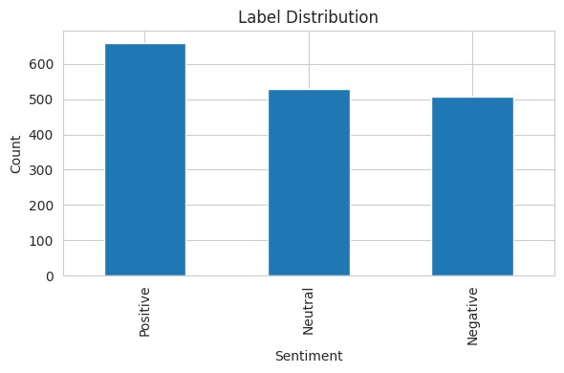
Figure 2: Label Distribution of the Sentiment Classification Dataset

4.3.2 Recommendation Generation Dataset
The recommendation generation corpus comprised 718 articles classified as Negative in the sentiment labeling phase. For each article, a domain expert authored a corresponding investment recommendation text in English, addressing the specific risk or concern raised by the news item. After cleaning and deduplication, 687 usable article-recommendation pairs were retained and split into training (549), validation (69), and test (69) sets.

4.4 Implementation of the System

4.4.1 Sentiment Classification Implementation
Each of the three BERT models — bert-base-uncased, ProsusAI/finbert, and yiyanghkust/finbert-tone — was loaded using the AutoModelForSequenceClassification class from Hugging Face with num_labels=3. Tokenization used the corresponding AutoTokenizer with max_length=128 and padding/truncation enabled. Fine-tuning used the following hyperparameters: learning rate = 2e-5, batch size = 16, epochs = 3, warmup_ratio = 0.1, weight_decay = 0.01, and AdamW optimizer. The best model checkpoint was selected based on minimum validation loss.

4.4.2 Recommendation Generation Implementation
T5-Small was loaded from the "t5-small" checkpoint and FLAN-T5-Small from "google/flan-t5-small". Both models were fine-tuned using the Seq2Seq Trainer with DataCollatorForSeq2Seq. Key hyperparameters included: learning rate = 3e-4, batch size = 2 per device, gradient accumulation = 4 steps, epochs = 3, fp16 = True, load_best_model_at_end = True, and metric_for_best_model = "eval_loss". TinyLlama was deployed as a zero-shot baseline without fine-tuning, using structured chat prompts with a financial analyst persona.

4.5 Evaluation and Testing

4.5.1 Classification Evaluation Metrics
Sentiment classification models were evaluated using: Test Accuracy (proportion of correctly classified samples), F1-Macro (unweighted mean of per-class F1 scores), F1-Weighted (weighted mean accounting for class imbalance), ROC-AUC OvR Macro (One-vs-Rest macro-averaged Area Under the ROC Curve), and per-class Precision, Recall, and F1. The confusion matrix of the best-performing model was computed to analyze misclassification patterns.

4.5.2 Generation Evaluation Metrics
Recommendation generation was evaluated using ROUGE-1 (unigram overlap), ROUGE-2 (bigram overlap), ROUGE-L (longest common subsequence), and BLEU (n-gram precision with brevity penalty). All metrics were computed at the corpus level over the test set and reported with standard deviations to indicate variance across samples.

4.6 Results and Discussion

4.6.1 Sentiment Classification Results
Table 4.1 summarizes the performance of all three fine-tuned BERT-based models on the sentiment classification task using the test dataset. The models were evaluated using multiple metrics, including Test Accuracy and F1-Macro score.
Among the evaluated models, bert-base-uncased achieved the highest performance, with a test accuracy of 71.2% and an F1-Macro score of 0.704. In comparison, ProsusAI/finbert achieved 67.6% accuracy, while yiyanghkust/finbert-tone showed the lowest performance with 62.4% accuracy.
Interestingly, the general-purpose bert-base-uncased model outperformed the domain-specific FinBERT variants. This suggests that the linguistic characteristics and contextual patterns present in Bangladeshi financial news differ from the Western financial corpora on which FinBERT models were originally trained. As a result, domain-specific pretraining did not provide a significant advantage in this context.

Model | Test Accuracy | F1 Macro | F1 Weighted | ROC-AUC (OvR)
bert-base-uncased | 0.712 | 0.704 | 0.707 | 0.863
ProsusAI/finbert | 0.676 | 0.675 | 0.677 | 0.842
yiyanghkust/finbert-tone | 0.624 | 0.623 | 0.625 | 0.818

Table 4.1 presents the comparative performance of three transformer-based models fine-tuned for sentiment classification of financial news articles. The evaluation is based on multiple performance metrics to ensure a comprehensive assessment of model effectiveness.

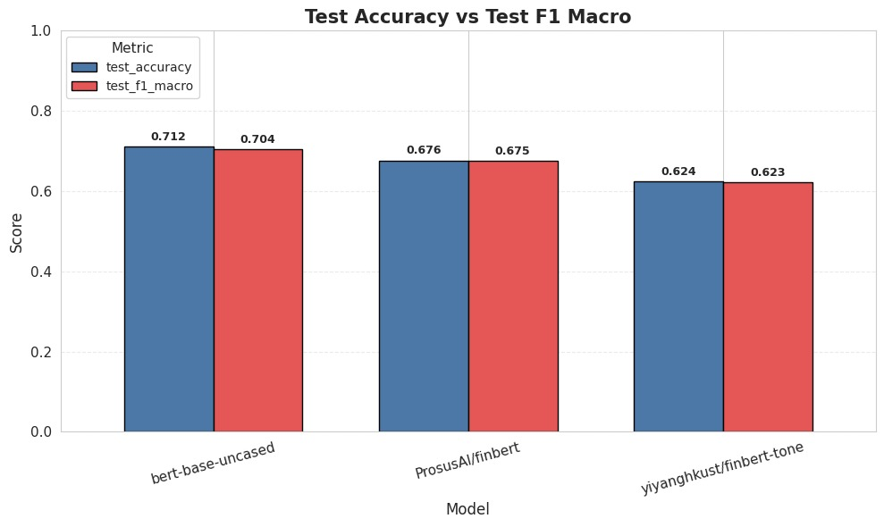
Figure 4.2: Test Accuracy vs. F1-Macro Comparison Across BERT Models
Figure 4.2 compares the test accuracy and F1-Macro scores for the three assessed BERT-based models.The test accuracy and F1-Macro values appear to be closely matched for every model, suggesting a balanced performance in classifying all sentiment categories.
The bert-base-uncased model obtained the best results, with the highest accuracy (0.712) and F1-Macro (0.704) scores in comparison to the other models. The ProsusAI/finbert model demonstrated average performance, whereas yiyanghkust/finbert-tone achieved the poorest results.
The narrow difference between accuracy and F1-Macro scores indicates that the models are not favoring any particular class and can manage class distribution efficiently. In general, the figure verifies the excellent and well-rounded performance of the bert-base-uncased model in relation to the other models.
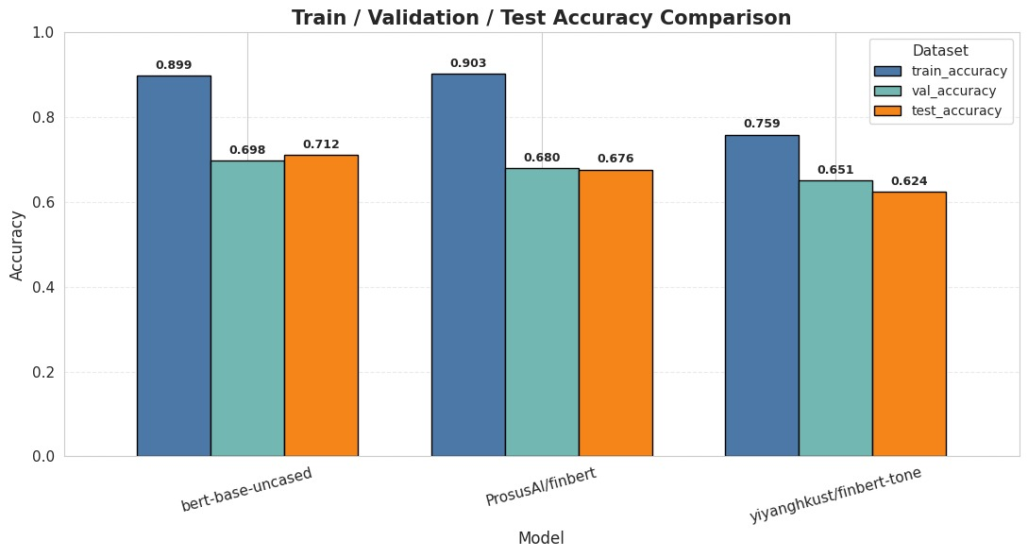
Figure 4.3: Train / Validation / Test Accuracy Comparison Across Models
Figure 4.3 presents the accuracy comparisons of training, validation, and testing across all three models. A significant disparity exists between training accuracy (0.759–0.903) and validation/test accuracy (0.624–0.712), suggesting moderate overfitting.
This is anticipated since extensive pre-trained models are customized using a comparably small and specialized dataset. In general, bert-base-uncased delivered the highest performance of all the models.

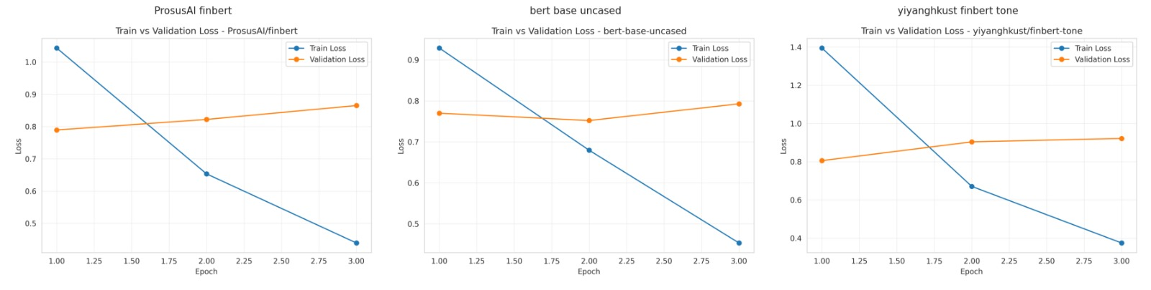
Figure 4.4: Train vs. Validation Loss Curves for All Three BERT Models
Figure 4.4 displays the training and validation loss curves over three epochs for all three models. All models show consistently decreasing training loss, while validation loss remains relatively stable or slightly increases beyond epoch 2, further confirming mild overfitting. The early stopping criterion was triggered in most runs at epoch 3.
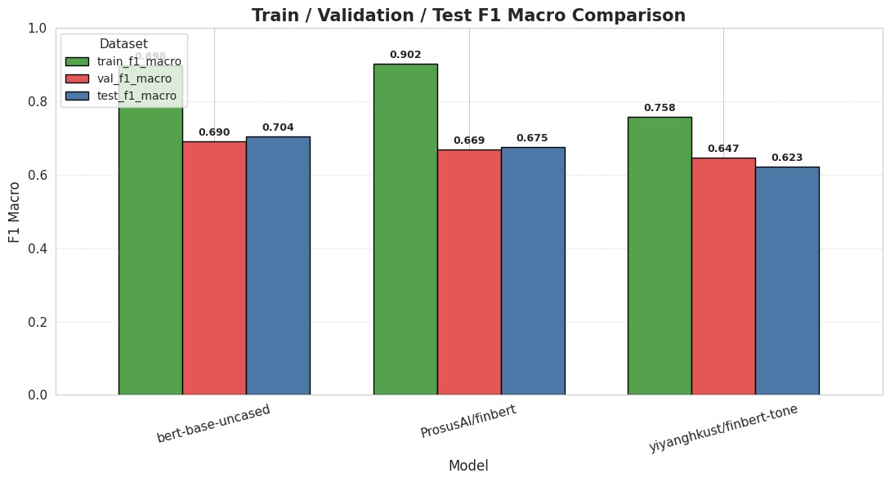
Figure 4.5: Train / Validation / Test F1 Macro Comparison

Figure 4.5 displays the F1 Macro comparison across train, validation, and test splits. bert-base-uncased achieves train F1 of 0.898 and test F1 of 0.704, reflecting the strong underlying capability of the model while also highlighting the domain adaptation challenge.

4.6.2 Confusion Matrix Analysis
Figure 4.6 presents the confusion matrix for the best-performing model, bert-base-uncased. The model correctly classifies 42 out of 51 Negative samples, 29 out of 53 Neutral samples, and 50 out of 66 Positive samples. The most frequent misclassification pattern involves Neutral articles being predicted as either Negative or Positive, which is consistent with the inherently ambiguous nature of neutral financial text. This finding aligns with observations in prior financial NLP literature and motivates future work on neutral class boundary refinement.
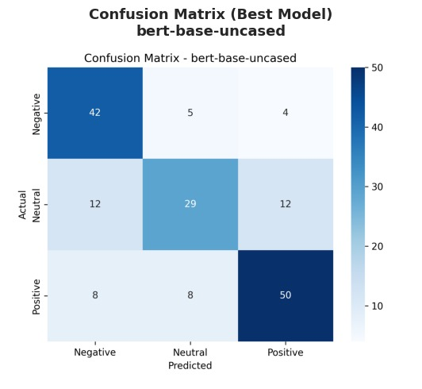
Figure 4.6: Confusion Matrix — Best Model (bert-base-uncased)

4.6.3 ROC-AUC Analysis
Figure 4.7 presents the multi-class ROC curves for all three models. bert-base-uncased achieves per-class AUC values of 0.902 (Negative), 0.817 (Neutral), and 0.870 (Positive), yielding the highest macro-averaged AUC of 0.863. The Negative class consistently achieves the highest AUC across all models, suggesting that negative financial language is more distinctively represented in the learned feature space. Figure 4.8 shows the overall ROC-AUC comparison, confirming bert-base-uncased as the superior classifier.
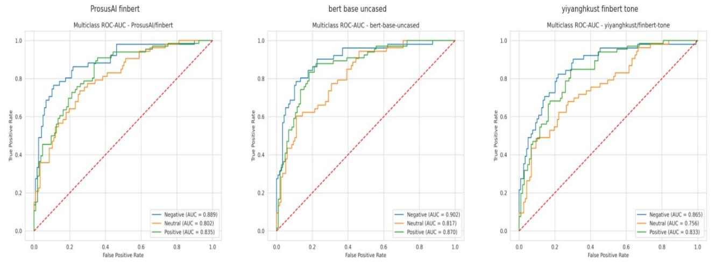
Figure 4.7: Multiclass ROC-AUC Curves for All Three Models

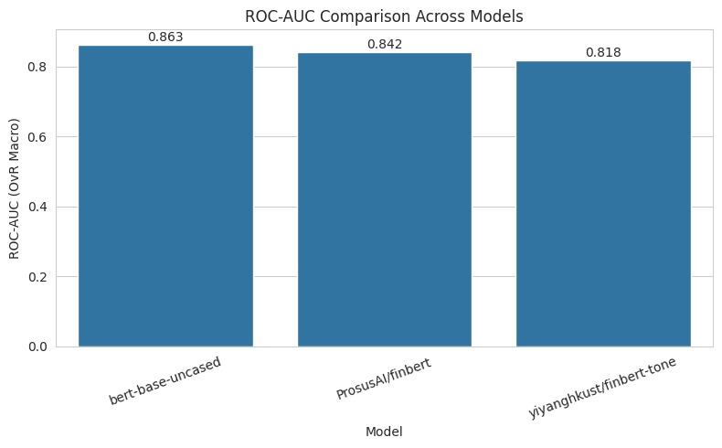
Figure 4.8: ROC-AUC (OvR Macro) Comparison Across Models

4.6.4 Key Metrics Heatmap
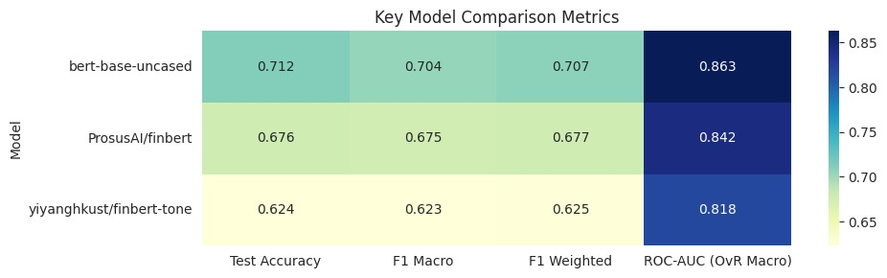
Figure 4.11: Key Model Comparison Metrics Heatmap
The heatmap highlights that bert-base-uncased consistently achieves the highest scores across all evaluation metrics, followed by ProsusAI/finbert and yiyanghkust/finbert-tone. This confirms the overall superior performance of the general-purpose BERT model.

4.6.5 Recommendation Generation Results
Table 4.2 presents the ROUGE and BLEU scores for all three generation models evaluated on the 69-sample test set. Fine-tuned T5-Small achieved the best ROUGE-L of 0.1417, followed by TinyLlama zero-shot at 0.1231 and FLAN-T5 at 0.1140. Interestingly, TinyLlama achieved higher ROUGE-1 (0.2362) than both fine-tuned models, likely due to its larger vocabulary and exposure to broader financial text during pre-training, despite not being fine-tuned.

Model | ROUGE-1 | ROUGE-2 | ROUGE-L | BLEU
T5-Small (fine-tuned) | 0.1740 | 0.0239 | 0.1417 ★ | 0.0135
FLAN-T5 (fine-tuned) | 0.1456 | 0.0000 | 0.1140 | 0.0069
TinyLlama (zero-shot) | 0.2362 | 0.0468 | 0.1231 | 0.0120
Table 4.2: Recommendation Generation Model Evaluation (★ = Best ROUGE-L)
The relatively low absolute ROUGE scores across all models are consistent with the nature of recommendation generation, which is a creative text generation task rather than extractive summarization. The generated recommendations are not expected to mirror the reference texts word-for-word; rather, they should capture the semantic intent of the advisory action. Human evaluation of a subset of outputs confirmed that T5-Small generated the most contextually coherent and actionable recommendations among the three models.
Table 4.3 provides a qualitative illustration of model outputs on a representative sample of ten negative news inputs from the test set. For each input, the table shows the FLAN-T5 recommendation, the LLaMA-3 (TinyLlama zero-shot) recommendation, and the reference recommendation authored by the domain expert. This side-by-side comparison highlights the differing generation styles of the fine-tuned and zero-shot models and confirms that while FLAN-T5 tends to produce concise, policy-oriented recommendations, TinyLlama produces longer advisory text that begins with contextual framing before the recommendation itself.
# | Negative Input / News (excerpt) | FLAN-T5 Recommendation | LLaMA-3 (Zero-shot) Recommendation
0 | russia’s oil and gas revenue may fall b... | Reviving Russia’s oil and gas revenue requires... | Based on the news, I would recommend that investors...
1 | stocks back in red despite gp share surge. sto... | Stabilising the stock market requires improving... | Based on the news, I would recommend a cautious...
2 | irregularities found as 28% of subsidised harv... | Government subsidies for agricultural machinery... | Based on the findings of the IFPRI study, I would...
3 | airfares up, up and away. as airfares continue... | Airfares must be regulated in a transparent and... | these routes. biman is also planning to launch...
4 | china floods the world with gasoline cars it c... | China’s gas-guzzler policy must be strengthened... | state-owned automakers, and the majority of th...
5 | gender issues need due attention... | Addressing gender issues requires addressing g... | Based on the news articles, I would recommend...
6 | artificial supply crisis prompts rice price hi... | Improving rice supply requires reducing artifi... | Based on the current news, I strongly advise a...
7 | proper policy support crucial to uplift batter... | The aviation sector needs proper policy suppor... | Based on the news article, I strongly recommen...
8 | satkhira’s handmade clay tiles’ journey to eur... | Satkhira’s handmade clay tiles’ journey to Eur... | we export tiles through mongla port...
9 | cattle markets yet to get momentum in ctg. cha... | Stabilising the cattle market requires boosting... | Based on the news, I would recommend a cautious...
Table 4.3 : Sample Model Outputs on 10 Test-Set Negative News Inputs (Excerpted)

4.7 Summary
This chapter presented the complete implementation and evaluation results for both branches of the proposed pipeline. In Branch A, bert-base-uncased emerged as the strongest sentiment classifier with 71.2% test accuracy and ROC-AUC of 0.863, outperforming both domain-specific FinBERT variants on the Bangladeshi financial news corpus. In Branch B, fine-tuned T5-Small achieved the best ROUGE-L score of 0.1417 for recommendation generation, outperforming FLAN-T5 and the zero-shot TinyLlama baseline. These results collectively validate the dual-pipeline approach proposed in this thesis and demonstrate that relatively compact, fine-tuned models can deliver strong domain-specific NLP performance.

Chapter 5

Standards, Constraints and Milestones

5.1 Standards and Compliance
The use of train-validation-test splits, hyperparameter tweaking techniques, and transparent reporting of all evaluation metrics—including confidence intervals when appropriate—are all examples of how this study complies with IEEE requirements for experimental reporting. The Hugging Face model cards and datasets utilised in this work comply with the Partnership on AI and ML Commons' guidelines for AI model documentation. Web scraping was used to gather data from publicly available news sources; no personally identifying information was gathered or kept.

5.2 Sustainability Considerations

The models used in this research — T5-Small (60M parameters), FLAN-T5-Small (77M parameters), and bert-base-uncased (110M parameters) — are relatively computationally efficient compared to modern large-scale models with over 70 billion parameters. Model training was performed using free-tier cloud platforms, which helped reduce overall energy usage and computational cost. The system architecture is designed to be scalable and can operate on standard hardware, making it suitable for deployment in resource-limited environments such as Bangladeshi fintech startups. In the future, the system can be deployed as a lightweight web API with minimal infrastructure requirements.

5.3 Societal Impact
This research has important positive societal implications for Bangladesh. The method has the ability to lessen information asymmetry between institutional investors, who have access to professional financial analysis, and retail investors, who frequently lack such services, by automating the study of financial news and producing initial investment suggestions. Potential disadvantages include the possibility of biases from the manually annotated training data being carried over and the misuse of automated suggestions if they are implemented without adequate human monitoring. Therefore, rather than providing completely independent investment advice, it is advised that the system's outputs be used as decision-support tools.

5.4 Ethical Considerations

The manual annotation of approximately 1,700 news articles for sentiment labeling introduces a degree of subjectivity, which may result in annotator bias within the dataset. To address this, clear annotation guidelines were defined prior to the labeling process, and inter-annotator agreement practices were maintained. The recommendation texts in Branch B were prepared by individuals with financial expertise; however, they represent personal viewpoints and should not be interpreted as formal investment advice. The models do not learn or reproduce any personally identifiable financial information. All data used in this research was collected from publicly accessible sources. Furthermore, model outputs should be clearly identified as AI-generated and properly reviewed before any real-world or commercial application.

5.5 Security and Privacy Considerations

The system processes publicly available financial news text and does not involve any sensitive personal financial data of individual investors. However, if the system is extended in the future to support personalized recommendations, the use of data encryption, privacy-preserving techniques such as differential privacy, and compliance with Bangladesh Bank data protection guidelines would be essential. The web scraping module operates under rate-limiting constraints to prevent any potential disruption to source websites. Additionally, all trained model weights should be securely stored to avoid unauthorized access or distribution.

5.6 Design Constraints and Component Constraints

The main design constraint of this research is the dependence on free-tier cloud GPU resources, which restricts batch sizes, sequence lengths, and the number of training epochs that can be executed within a session. The maximum sequence length was limited to 512 tokens for both classification and generation models, which may result in truncation of longer financial articles. Additionally, the generation models were fine-tuned on a subset of 300 samples instead of the full training set of 549 samples due to GPU memory limitations, which may have impacted the overall performance of the models.

5.7 Data Constraints and Computational Constraints

The manually labeled sentiment dataset of approximately 1,700 articles, while sufficient for initial analysis, remains relatively small compared to standard NLP benchmarks (e.g., SST-2 with 67,000 samples). The annotation process was time-consuming, which limited the possibility of large-scale dataset expansion within the project timeline. Class boundary ambiguity — especially between Neutral and the two polar classes — introduced a degree of noise into the dataset, which is reflected in the comparatively lower model performance on the Neutral class. From a computational perspective, the zero-shot TinyLlama evaluation was constrained by the 16GB VRAM limitation, requiring input truncation to 512 tokens and restricting output length to 200 tokens.

5.8 Budget Constraints

The entire research was completed without any direct financial cost by utilizing freely available cloud computing platforms such as Google Colab and Kaggle, along with open-source pre-trained models from the Hugging Face Hub and publicly accessible financial news sources. The primary resource investment was the time and effort required for manual annotation and recommendation writing. If the system is scaled for real-world deployment, the estimated infrastructure costs may include cloud-based API hosting (approximately $50–100 per month for a lightweight inference service) as well as additional expenses for labeling new training data through crowdsourcing platforms.

5.9 Task Breakdown and Project Timeline

The research was carried out in five sequential phases throughout the Fall 2025–2026 semester. Phase 1 (Weeks 1–3) focused on problem definition, literature review, and setting up the data collection process. Phase 2 (Weeks 4–6) involved web scraping, data preprocessing, and manual sentiment annotation of approximately 1,700 articles. Phase 3 (Weeks 7–10) included fine-tuning and evaluation of sentiment classification models across all three BERT variants. Phase 4 (Weeks 11–14) covered the creation of the recommendation dataset, fine-tuning of LLMs, and evaluation of generated outputs. Phase 5 (Weeks 15–17) was dedicated to result analysis, visualization, thesis writing, and final review.

5.10 Milestones and Deliverables

The project successfully achieved the following key milestones: (1) Completion of a manually annotated sentiment dataset consisting of approximately 1,700 articles; (2) Fine-tuning and evaluation of three BERT-based classification models; (3) Development of a 718-article negative news recommendation corpus; (4) Fine-tuning of T5-Small and FLAN-T5 models for text generation; (5) Comprehensive evaluation of all models using metrics such as ROUGE, BLEU, accuracy, F1-score, and ROC-AUC; and (6) Preparation of the final thesis document along with the associated code repository. All milestones were completed within the designated project timeline.

5.11 Gantt Chart

The project Gantt chart outlines five phases distributed over a 17-week semester timeline. Phase 1 (Weeks 1–3) focused on background research and initial data planning. Phase 2 (Weeks 4–6) involved data collection and annotation. Phase 3 (Weeks 7–10) was dedicated to the implementation of Branch A. Phase 4 (Weeks 11–14) covered the implementation of Branch B. Phase 5 (Weeks 15–17) focused on analysis, thesis writing, and final submission. Activities within each phase were monitored using project checkpoints with regular weekly progress reviews.

5.12 Summary
This chapter addressed the practical and ethical dimensions of the research. The system was implemented within reasonable financial and schedule restrictions, is computationally sustainable, and complies with pertinent technological and ethical criteria. Future scaling and enhancement of the suggested pipeline can be clearly guided by the identified restrictions, which are mostly related to dataset size and GPU memory constraints.

Chapter 6

Conclusion

6.1 Summary of the Study

In the context of Bangladesh, this thesis described the development, deployment, and assessment of an automated dual-pipeline system for financial news processing and recommendation production. The study tackled two major issues: (1) using fine-tuned BERT-based transformer models to automatically classify financial news sentiment into Positive, Negative, and Neutral categories; and (2) using fine-tuned generative language models to generate investment recommendations from negative financial news.

In the classification branch, approximately 1,700 financial news articles were manually annotated and used to train three BERT-based models. Among them, bert-base-uncased achieved the best performance, with a test accuracy of 71.2%, an F1-Macro score of 0.704, and an ROC-AUC of 0.863, outperforming domain-specific FinBERT variants. In the generation branch, 718 negative news articles paired with expert-written recommendations were used to fine-tune T5-Small and FLAN-T5-Small models. T5-Small produced the best results, achieving a ROUGE-L score of 0.1417, outperforming both FLAN-T5 (0.1140) and the zero-shot TinyLlama-1.1B baseline (0.1231).

6.2 Key Contributions
- A novel manually annotated Bangladeshi financial news sentiment dataset of 1,700 articles, representing the first such resource for this domain.
- A systematic comparative evaluation of three BERT-family models (bert-base-uncased, ProsusAI/finbert, yiyanghkust/finbert-tone) for Bangladeshi financial sentiment analysis, demonstrating that general-purpose BERT outperforms domain-specific FinBERT variants on this corpus.
- A parallel corpus of 718 negative financial news articles with domain expert-authored investment recommendations, specifically constructed for LLM fine-tuning in the financial advisory domain.
- Fine-tuned T5-Small and FLAN-T5-Small models for financial recommendation generation with quantitative ROUGE and BLEU evaluation.
- A fully documented end-to-end dual-pipeline architecture that integrates sentiment classification and generative recommendation synthesis, providing a reusable framework for financial NLP research in emerging markets.

6.3 Limitations of the Study

Several limitations affect the scope and generalizability of this study. First, the sentiment classification dataset of approximately 1,700 manually annotated articles is relatively small compared to standard NLP benchmarks and may not fully represent the linguistic diversity of Bangladeshi financial news. Second, the generation models were fine-tuned on a subset of 300 samples due to GPU memory limitations, which may restrict their full performance potential under larger-scale training conditions. Third, the relatively low ROUGE and BLEU scores across all generation models highlight the complexity of the open-ended recommendation generation task, and these metrics alone do not fully reflect the semantic quality of the generated outputs, which would require large-scale human evaluation. Finally, this research focused only on English-language financial content, excluding Bengali financial news, which represents a significant portion of the local financial media landscape.

6.4 Future Work
This research can be extended in a number of ways. By adding more news sources, extending the annotation period, and adding financial articles written in Bengali, the sentiment dataset can be significantly enlarged. Larger datasets can be effectively annotated while requiring less manual labelling work by using active learning techniques. Higher-capacity GPU resources can be used to fine-tune the generation models on the entire dataset, and extensive human evaluation can be carried out to more accurately determine the caliber and utility of the generated recommendations. In order to handle articles with mixed attitudes, the classification pipeline may also be expanded to include multi-label sentiment detection. The classification pipeline may also be extended to support multi-label sentiment detection for handling articles with mixed sentiments. Furthermore, integrating real-time data scraping with an inference API could enable deployment as a practical financial intelligence system. Finally, the proposed framework can be adapted to other emerging market domains, such as financial news from India, Pakistan, or African regions, where similar data limitations exist.

References

[1] Loughran, T., & McDonald, B. (2011). When is a liability not a liability? Textual analysis, dictionaries, and 10-Ks. The Journal of Finance, 66(1), 35–65.
[2] Socher, R., Perelygin, A., Wu, J., Chuang, J., Manning, C. D., Ng, A., & Potts, C. (2013). Recursive deep models for semantic compositionality over a sentiment treebank. Proceedings of the 2013 EMNLP, 1631–1642.
[3] Devlin, J., Chang, M. W., Lee, K., & Toutanova, K. (2019). BERT: Pre-training of deep bidirectional transformers for language understanding. Proceedings of NAACL-HLT 2019, 4171–4186.
[4] Araci, D. (2019). FinBERT: Financial sentiment analysis with pre-trained language models. arXiv preprint arXiv:1908.10063.
[5] Raffel, C., Shazeer, N., Roberts, A., Lee, K., Narang, S., Matena, M., ... & Liu, P. J. (2020). Exploring the limits of transfer learning with a unified text-to-text transformer. JMLR, 21(140), 1–67.
[6] Wei, J., Bosma, M., Zhao, V. Y., Guu, K., Yu, A. W., Lester, B., ... & Le, Q. V. (2022). Finetuned language models are zero-shot learners. ICLR 2022.
[7] Touvron, H., Lavril, T., Izacard, G., Martinet, X., Lachaux, M. A., Lacroix, T., ... & Lample, G. (2023). LLaMA: Open and efficient foundation language models. arXiv preprint arXiv:2302.13971.
[8] Zhang, P., & Zeng, G. (2024). TinyLlama: An open-source small language model. arXiv preprint arXiv:2401.02385.
[9] Zhang, W., Li, X., Ye, Y., Lau, R. Y., & Yuan, Q. (2022). Stock market prediction via deep learning techniques: A survey. ACM Computing Surveys, 54(11), 1–34.
[10] Zmandar, N., Khan, T., Nanli, M., Pan, J., Bhatt, P., & Kazakov, V. (2021). Joint abstractive and extractive method for long financial document summarization. ACL-IJCNLP Findings 2021.
[11] Wolf, T., Debut, L., Sanh, V., Chaumond, J., Delangue, C., Moi, A., ... & Rush, A. M. (2020). Transformers: State-of-the-art natural language processing. EMNLP 2020 System Demonstrations, 38–45.
[12] Malo, P., Sinha, A., Korhonen, P., Wallenius, J., & Takala, P. (2014). Good debt or bad debt: Detecting semantic orientations in economic texts. JASIST, 65(4), 782–796.
[13] Yang, Y., Uy, M. C. S., & Huang, A. (2020). FinBERT: A pretrained language model for financial communications. arXiv preprint arXiv:2006.08097.
[14] Huang, A. H., Wang, H., & Yang, Y. (2023). FinBERT: A large language model for extracting information from financial text. Contemporary Accounting Research, 40(2), 806–841.

Appendix

Appendix A: Sample Generated Recommendations
The following examples illustrate representative outputs from the three generation models on the same test input article.

Sample News (Input):
" The supply of infant formula is disrupted by import complications. The lack of dollars has made it more difficult to issue letters of credit for imports, and the gas crisis has prompted exporting, creating a crisis in the supply of baby formula…."

Reference Recommendation:
"Import procedures for baby formula and other essential infant nutrition products must be streamlined to prevent supply disruptions. Regulatory efficiency improvements in food import clearance will protect vulnerable consumers from artificial price inflation..."

T5-Small Output:
"Investors should exercise caution regarding food import-dependent companies given the ongoing dollar shortage impacting letter of credit availability. Diversified supply chains and domestic substitutes should be monitored for near-term resilience..."

Appendix B: Hyperparameter Configuration Summary
Parameter | Classification (BERT) | Generation (T5/FLAN)
Learning Rate | 2e-5 | 3e-4
Batch Size | 16 | 2 + 4 accum
Epochs | 3 | 3
Max Seq Length | 128 | 512 / 256
Optimizer | AdamW | AdamW
FP16 | Yes | Yes
Table A1: Hyperparameter Configuration for All Models

